TIẾNG ANH LỚP 6
UNIT 2 : SCHOOL
Periods 13 (Page 14 - Student’s book)

- New Words :
- history (n) /ˈhɪstəri/ : môn Lịch sử
- P.E. (n) /ˌpiːˈiː/
Physical Education /ˈfɪz·ɪ·kəl ˌedʒ·əˈkeɪ·ʃən/ : môn Thể dục
- I.T.(n) /aiti/
Information Technology /ɪn.fəˌmeɪ.ʃən tekˈnɒl.ə.dʒi/ : môn Tin học
- music (n) /ˈmjuː.zɪk/ : môn Âm nhạc
- geography (n) /dʒiˈɒɡ.rə.fi/ : môn Địa lý
- literature (n) /ˈlɪt.rə.tʃər/ : môn Ngữ văn
- physics (n) /ˈfɪz.ɪks/ : môn Vật lý
- biology (n) /baɪˈɒl.ə.dʒi/ : môn Sinh học

Ask and answer: Do you like math? _ Yes, I do.

Practice with your partner:
Ex: Student A : Do you like …….?
Student B : Yes, I do / No, I don’t. I like ……….
Unscramble words:
1. maforintion lonogytech : _______________________
2. lobiogy : _______________________
3. tuliareter : _______________________
4. ophygegra: _______________________
5. alsiphyc cionadute : _______________________
6. yhotris : _______________________

- Listening:
- Who likes more school subjects? Adrian Sarah
- Listen and fill in the blanks:
- Adrian likes
- Sarah likes history, physics, and
- Sarah doesn’t like
- Adrian’s favorite subject is

UNIT 2 : SCHOOL
Periods 14 (Page 15 - Student’s book)

- Grammar:
- Using and / or for listing
- I like math and biology.
- I like math, biology, and music.

- I don’t like math or biology.
- I don’t like math, biology, or music.
Notes : We use “and” to join two or more nouns in a positive sentence. We use “or” to join two or more nouns in a negative sentence (not).

- Possessive pronouns mine and yours

Student A: My favorite subject is physics. (What’s your favorite subject?)
What’s yours?
Student B: My favorite subject is English.
Mine is English.
*Possessive Adjective * Possessive Pronouns
(Tính từ sở hữu) ( Đại từ sở hữu)
My mine
Your yours
His his
Her hers
Its its
Our ours
Their theirs
Noun after Possessive Adjective No noun after Possessive Pronouns
Examples :
- This is my car . → This car is mine.
- This is their house. → This house is theirs.
- This is our kitchen. → This kitchen is ours.
- This is his special moment. → This special moment is his.

- Practice:
Circle the correct words:
- My favorite sport is tennis. What’s mine/ yours? - I like soccer.
- I found a bag. Is it mine / yours? - No, it isn’t. My bag is here.
- This book isn’t my book. Mine / Yours is blue. Is it yours? - Yes, it is.
- I saw a red hat on the table. Isn’t yours / mine red? - No, mine is blue.
- What’s your favorite ice cream? Mine / Yours is chocolate. - I like chocolate, too.
- Do you have a ruler? Mine /Yours is at home. - Sure, here you are.

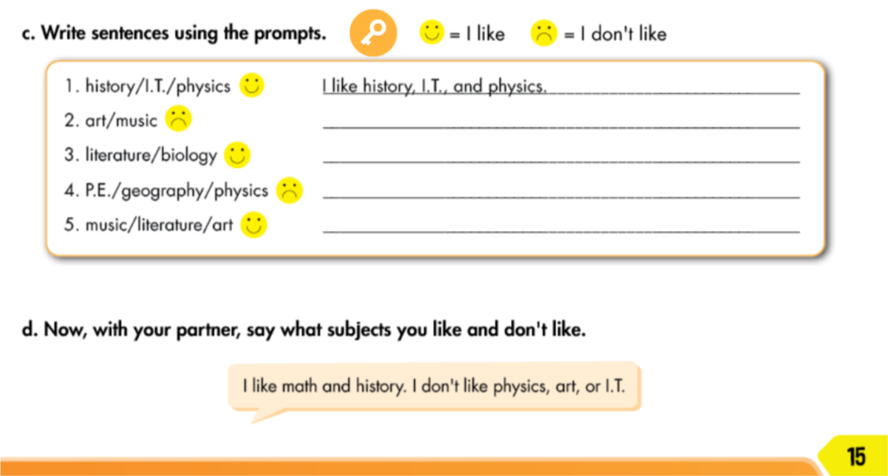

EXERCISES
- Match each vocabulary item with its English definition or description :
- history a. a school subject about works or poems
from writers or poets.
- P.E b. a school subject about how to sing songs
(Physical Education ) or play musical instrument.
- I.T. c. a school subject about features of the
(Information Technology ) areas or places around us such as climate,
weather, or people.
- music d. a school subject about past events.
- geography e. a school subject about matters and energy
such as movements, heats, light, and sound
- literature f. a school subject about living things such
as humans, animals, or plants
- physics g. a school subject about how to use computers.
- biology h. a school subject about how to play sports
or do body movements to have good health.

- , 2. , 3. , 4. ,
5. , 6. , 7. , 8.

- Fill out the correct possessive pronoun :
- I have a dog. That dog is _________.
- She has a cat. That cat is _________.
- We have a car. That car is ________.
- They have a bike. That bike is ________.
- He has a key. That key is _________.
- You have a hat. That hat is _________.

